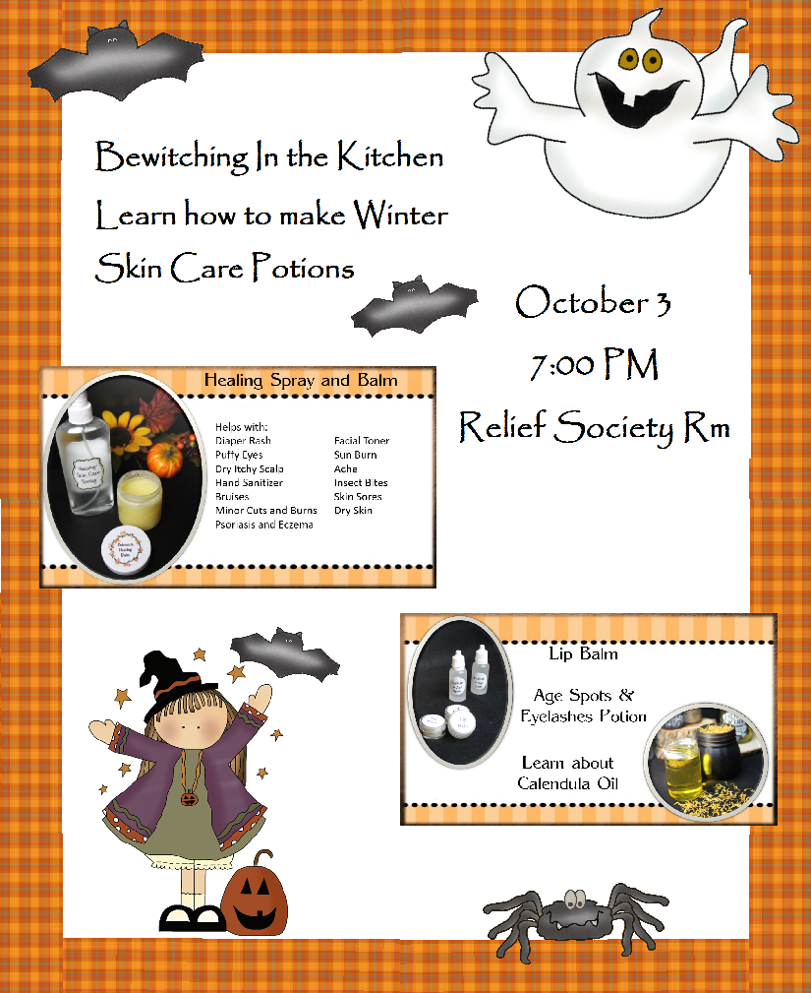
Poster Instructions
Using a color printer, print the color PDF poster file (pages 2-5). The file can also be taken to a copy store and printed there. That file is saved in PDF format to freeze the pictures so there won’t be any issues when the file is printed.
Follow the cutting instructions on each of the 4 pages. I like to laminate the color pictures and boarder because the poster can be used again for a different Oct class.
Place the border pieces on the white board, or poster board, following the example to the left. If you purchased the white dry erase board, you might want round the corners of the border so they will follow the curve of the white board.
Add the 2 skin care pictures and the other misc. pictures and place them as pictured on the left. I usually roll tape circles and place the tape on the back of the border and pictures. .
This is the second file, in Microsoft Office Word format. You need to put the correct information for the date, location and time of the class. Page 2 can be printed on white regular paper of card stock. Cut the boxes on the outline and then attach it to the poster.
Signup Sheet Instructions
The only time you might need a signup sheet is if you want to make or buy samples for the class participants. I made the sheet on this Word file so that you could customize it. It can be printed on white paper. Put the sheet on a clip board. Attach a pen or pencil to a string and then attach to the clip board. Pass around for the people to sign up
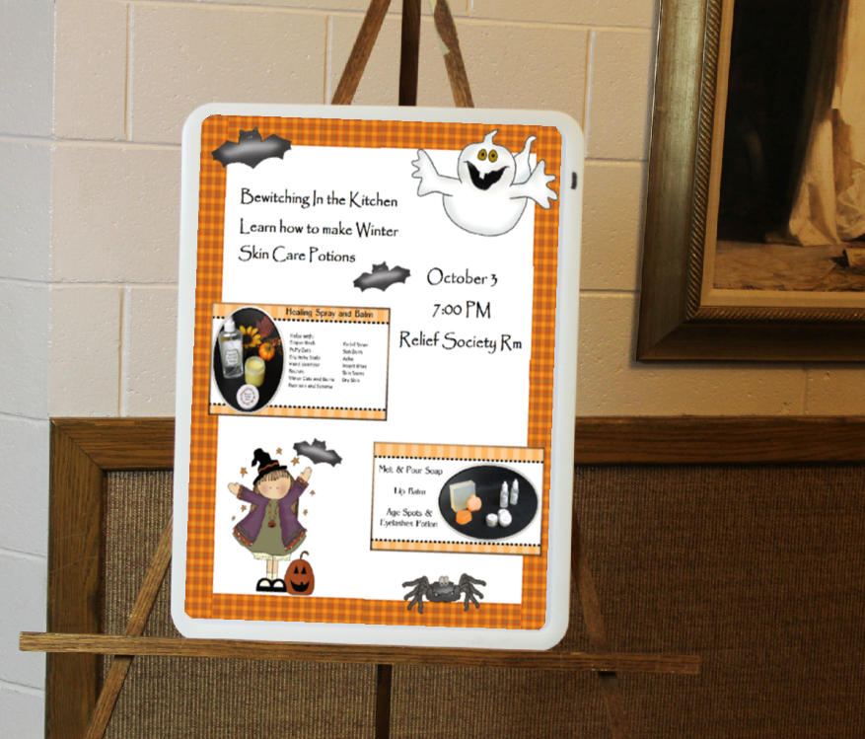
Invitation Instructions
The invitation/handout is also on this Word file. Enter the correct information and then print the page on regular paper. I made this file in black and white so the invitations could be printed or copied cheaper and wouldn’t require color. You can also print the invitation on card stock paper. Make the number of copies of the invite so you will have enough to pass out several times. Cut the invite with a paper trimmer, or by using scissors, along the black lines. Another option is to cut off the black lines using decorative scissors.
Clipart was purchased from
Cheryl Seslar designs- www.cherylseslar.com
You do not have permission to give this file to anyone. Please direct them to www.homemakingdivas.com to purchase their own copy.
EMAIL QUESTIONS TO: stacy@homemakingdivas.com
October 3
7:00 PM
Taylorsville 3rd Ward
Relief Society Rm
Young Women invited

The font to use when making the Date time and location section of the poster is:
Papyrus bold font size 48

The longer lines:
Taylorsville 3rd ward
And
Young Women invited
Are font size 40

Bewitching in the Kitchen learning how to make Winter Skin
Care Potions

Bewitching in the Kitchen
Learning how to make Winter Skin Care Potions
October 3 7:00 PM
Relief Society Rm - Young Women invited

SIGN UP IF YOU WANT TO BUY SAMPLES OF
LIP BALM AND THE AGE SPOT POTION
Pay money to __________ before September 22

Name and phone # | Lip Balm $ | Age Spot Potion $

Bewitching in the Kitchen
Learning how to make
Winter Skin Care Potions

October 3 7:00 PM

Relief Society Rm - Young Women invited
Sign up if you want to buy samples of Lip Balm and the Age Spot Potion
Pay money to __________ before September 22

Bewitching in the Kitchen
Learning how to make
Winter Skin Care Potions

October 3 7:00 PM

Relief Society Rm - Young Women invited
Sign up if you want to buy samples of Lip Balm and the Age Spot Potion
Pay money to __________ before September 22

Bewitching in the Kitchen
Learning how to make
Winter Skin Care Potions

October 3 7:00 PM

Relief Society Rm - Young Women invited
Sign up if you want to buy samples of Lip Balm and the Age Spot Potion
Pay money to __________ before September 22

Bewitching in the Kitchen
Learning how to make
Winter Skin Care Potions

October 3 7:00 PM

Relief Society Rm - Young Women invited
Sign up if you want to buy samples of Lip Balm and the Age Spot Potion
Pay money to _______ before September 22

